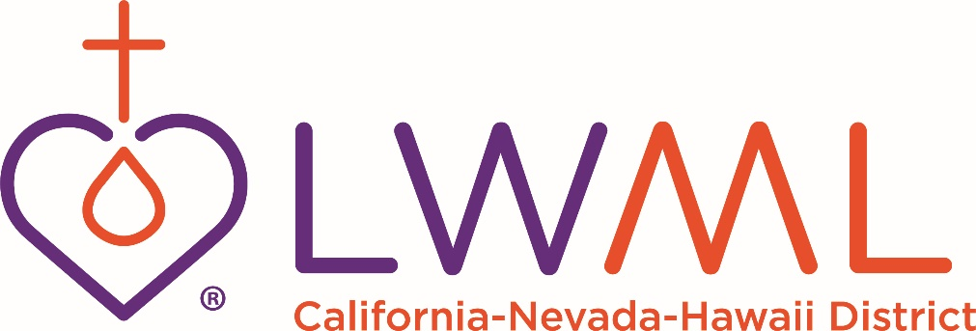
REMITTANCE FORM for MITES
and SCHOLARSHIP / MEMORIAL / ENDOWMENT FUNDS
Date Zone #
Society Name
Church Name
Church Address/City/State
Church email
Sender’s Name
Sender’s Email Address & Phone #
MITE OFFERING: $
(50% CNH Mission Grants | 25% General Fund | 25% LWML)
BITES FOR MITES OFFERING: $
(75% CNH Mission Grants | 25% LWML)
RUBIN PERPETUAL SCHOLARSHIP FUND (100%): $
STEINBECK MEMORIAL SCHOLARSHIP FUND (100%): $
OTHER*: $
*Please Specify:

Make checks payable to: LWML CNH
Send completed Remittance Form & check(s) to CNH District Financial Secretary
Barbara Guevara
PO Box 1522
Millbrae, CA 94030-5522
Email: tisbarb@sbcglobal.net
Make copies of this form as needed. Send one copy with your remittance.

