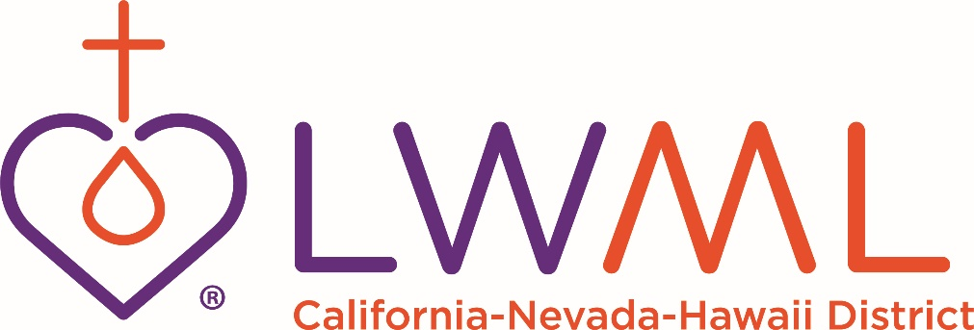
YEARLY PRO-RATE REMITTANCE FORM
Pro-rate is due annually January 1, deadline is February 15. The rate is $5.00 per member.
Pro-rate is used to assist delegates in paying for transportation cost to District conventions. If not paid yearly, your society’s delegate will not receive funds for mileage to convention.
Please complete the form below and mail it with your check.
Date Zone #
Number of Members: Pro-Rate Submitted: $
Society Name
Church Name/City/State
Church Email Address
Society Contact Name
Society Contact Email Address
Society Contact Phone #
Make Checks Payable to: LWML CNH
Mail Form and Check to: Barbara Guevara
PO Box 1522
Millbrae, CA 94030-5522
Pro-Rate Questions Email: tisbarb@sbcglobal.net

